Organization Name
Organizational Execution Plan

Version 1.02
July 2, 2012

Developed by:
Author Names

Executive Summary:
[Abstract]
Click here to enter text.

This template is a tool that is provided to assist in the development of an Organizational BIM Assessment Document. The template Document was created from the buildingSMART alliance™ (bSa) Project “BIM Execution Planning for Owners” as developed by The Computer Integrated Construction (CIC) Research Group of The Pennsylvania State University. The bSa project is sponsored by The Charles Pankow Foundation, US DoD Military Health System, Kaiser Permanente, US Department of Veterans Affairs, Penn State Office of Physical Plant (OPP), and The Partnership for Achieving Construction Excellence (PACE). The BIM Execution Planning Guide for Owners can be downloaded at http://bim.psu.edu.
This work is licensed under the Creative Commons Attribution-Share Alike 3.0 United States License. To view a copy of this license, visit http://creativecommons.org/licenses/by-sa/3.0/us/ or send a letter to Creative Commons, 171 Second Street, Suite 300, San Francisco, California, 94105, USA.

Table of Contents
Executive Summary: 1
1 Strategy: 3
1.1 Organizational Mission and BIM Vision 3
1.2 Organizational Goals and BIM Objectives 3
1.3 Planning Team Members: 4
2 BIM Uses 5
3 Process 6
3.1 Current Organizational Processes 6
3.2 Target Processes 6
3.3 Advance Process 6
4 Information 7
5 Infrastructure 11
5.1 Software 11
5.2 Hardware 11
5.3 Physical Spaces 12
6 Personnel 13
6.1 Organizational Structure 13
6.2 BIM Roles and Responsibilities 13
6.3 Education and Training Program 13
6.3.1 BIM Education Program Summary 14
6.3.2 BIM Training Program Summary 14
7 BIM Use 1 15
7.1 Organizational Goal and BIM Objective 15
7.1.1 Responsible Parties 16
7.2 Process 17
7.2.1 Current Process 17
7.2.2 BIM Process 18
7.2.3 BIM Use Advancement Process 19
7.3 BIM Use Information Needs 20
7.4 Infrastructure 21
7.4.1 BIM Use Software Needs 21
7.4.2 Hardware 21
7.4.3 Physical Spaces 21
7.5 Personnel 22
7.5.1 BIM Roles and Responsibilities 22
7.5.2 Education and Training Program 22
7.5.3 Change Management 22
8 Attachments: 23

Strategy:
(What is this document about? What is the purpose of this Organizational Execution Plan?)

Organizational Mission and BIM Vision
(Include a summary of the Organizational Mission)

(Include a summary of the Organizational Vision)

Organizational Goals and BIM Objectives
(Include a summary of the Organizational Goals)

Table 1-1: Organizational Goals
Priority | Goal Description | Objective
Choose an item.

Planning Team Members:
(Document the members of the BIM Planning Team. )
Name | Role | Department | E-Mail | Phone
 | BIM Champion
 | Discipline Lead

BIM Uses
(Summary of the current processes and Uses provided)
Table 2-1: Services Provided
X | Current Process | BIM USE | Descritpion | Current Maturity | Desired Maturity

Process
(Document how the organization performs work

Current Organizational Processes
(Summary of organizational Process)

Figure 3-1: Organizational Hierarchal Structure

Target Processes

Advance Process

Information
Model Element Breakdown |  |  |  | LoD | Facility Data | Notes
01 | SUBSTRUCTURE |  |  | 100
01 | 10 | Foundations |  | LoD
01 | 10 | 10 | Standard Foundations | LoD
01 | 10 | 20 | Special Foundations | LoD
01 | 20 | Subgrade Enclosures |  | LoD
01 | 20 | 10 | Walls for Subgrade Enclosures | LoD
01 | 40 | Slabs-On-Grade |  | LoD
01 | 40 | 10 | Standard Slabs-On-Grade | LoD
01 | 40 | 20 | Structural Slabs-On-Grade | LoD
01 | 40 | 30 | Slab Trenches | LoD
01 | 40 | 40 | Pits and Bases | LoD
01 | 40 | 50 | Slab-On-Grade Supplementary Components | LoD
01 | 60 | Water and Gas Mitigation |  | LoD
01 | 60 | 10 | Building Subdrainage | LoD
01 | 60 | 20 | Off-Gassing Mitigation | LoD
01 | 90 | Substructure Related Activities |  | LoD
01 | 90 | 10 | Substructure Excavation | LoD
01 | 90 | 20 | Construction Dewatering | LoD
01 | 90 | 30 | Excavation Support | LoD
01 | 90 | 40 | Soil Treatment | LoD
02 | SHELL |  |  | LoD
02 | 10 | Superstructure |  | LoD
02 | 10 | 10 | Floor Construction | LoD
02 | 10 | 20 | Roof Construction | LoD
02 | 10 | 30 | Stairs | LoD
02 | 20 | Exterior Vertical Enclosures |  | LoD
02 | 20 | 10 | Exterior Walls | LoD
02 | 20 | 20 | Exterior Windows | LoD
02 | 20 | 50 | Exterior Doors and Grilles | LoD
02 | 20 | 70 | Exterior Louvers and Vents | LoD
02 | 20 | 80 | Exterior Wall Appurtenances | LoD
02 | 20 | 90 | Exterior Wall Specialties | LoD
02 | 30 | Exterior Horizontal Enclosures |  | LoD
02 | 30 | 10 | Roofing | LoD
02 | 30 | 20 | Roof Appurtenances | LoD
02 | 30 | 40 | Traffic Bearing Horizontal Enclosures | LoD
02 | 30 | 60 | Horizontal Openings | LoD
02 | 30 | 80 | Overhead Exterior Enclosures | LoD
03 | INTERIORS |  |  | LoD
03 | 10 | Interior Construction |  | LoD
03 | 10 | 10 | Interior Partitions | LoD
03 | 10 | 20 | Interior Windows | LoD
03 | 10 | 30 | Interior Doors | LoD
03 | 10 | 40 | Interior Grilles and Gates | LoD
03 | 10 | 60 | Raised Floor Construction | LoD
03 | 10 | 70 | Suspended Ceiling Construction | LoD
03 | 10 | 90 | Interior Specialties | LoD
03 | 20 | Interior Finishes |  | LoD
03 | 20 | 10 | Wall Finishes | LoD
03 | 20 | 20 | Interior Fabrications | LoD
03 | 20 | 30 | Flooring | LoD
03 | 20 | 40 | Stair Finishes | LoD
03 | 20 | 50 | Ceiling Finishes | LoD
04 | SERVICES |  |  | LoD
04 | 10 | Conveying |  | LoD
04 | 10 | 10 | Vertical Conveying Systems | LoD
04 | 10 | 30 | Horizontal Conveying Systems | LoD
04 | 10 | 50 | Material Handling | LoD
04 | 10 | 80 | Operable Access Systems | LoD
04 | 20 | Plumbing |  | LoD
04 | 20 | 10 | Domestic Water Distribution | LoD
04 | 20 | 20 | Sanitary Drainage | LoD
04 | 20 | 30 | Building Support Plumbing Systems | LoD
04 | 20 | 50 | General Service Compressed-Air | LoD
04 | 20 | 60 | Process Support Plumbing Systems | LoD
04 | 30 | Heating, Ventilation and Air Conditioning (HVAC) |  | LoD
04 | 30 | 10 | Facility Fuel Systems | LoD
04 | 30 | 20 | Heating Systems | LoD
04 | 30 | 30 | Cooling Systems | LoD
04 | 30 | 50 | Facility HVAC Distribution Systems | LoD
04 | 30 | 60 | Ventilation | LoD
04 | 30 | 70 | Special Purpose HVAC Systems | LoD
04 | 40 | Fire Protection |  | LoD
04 | 40 | 10 | Fire Suppression | LoD
04 | 40 | 30 | Fire Protection Specialties | LoD
04 | 50 | Electrical |  | LoD
04 | 50 | 10 | Facility Power Generation | LoD
04 | 50 | 20 | Electrical Service and Distribution | LoD
04 | 50 | 30 | General Purpose Electrical Power | LoD
04 | 50 | 40 | Lighting | LoD
04 | 50 | 50 | Miscellaneous Electrical Systems | LoD
04 | 60 | Communications |  | LoD
04 | 60 | 10 | Data Communications | LoD
04 | 60 | 20 | Voice Communications | LoD
04 | 60 | 30 | Audio-Video Communication | LoD
04 | 60 | 60 | Distributed Communications and Monitoring | LoD
04 | 60 | 90 | Communications Supplementary Components | LoD
04 | 70 | Electronic Safety and Security |  | LoD
04 | 70 | 10 | Access Control and Intrusion Detection | LoD
04 | 70 | 30 | Electronic Surveillance | LoD
04 | 70 | 50 | Detection and Alarm | LoD
04 | 70 | 70 | Electronic Monitoring and Control | LoD
04 | 70 | 90 | Electronic Safety and Security Supplementary Compoenents | LoD
04 | 80 | Integrated Automation |  | LoD
04 | 80 | 10 | Integrated Automation Facility Controls | LoD
05 | EQUPMENT AND FURNISHINGS |  |  | LoD
05 | 10 | Equipment |  | LoD
05 | 10 | 10 | Vehicle and Pedestrian Equipment | LoD
05 | 10 | 30 | Commercial Equipment | LoD
05 | 10 | 40 | Institutional Equipment | LoD
05 | 10 | 60 | Residential Equipment | LoD
05 | 10 | 70 | Entertainment and Recreational Equipment | LoD
05 | 10 | 90 | Other Equipment | LoD
05 | 20 | Furnishings |  | LoD
05 | 20 | 10 | Fixed Furnishings | LoD
05 | 20 | 50 | Movable Furnishings | LoD
06 | SPECIAL CONSTRUCATION AND DEMOLITION |  |  | LoD
06 | 10 | Special Construction |  | LoD
06 | 10 | 10 | Integrated Construction | LoD
06 | 10 | 20 | Special Structures | LoD
06 | 10 | 30 | Special Function Construction | LoD
06 | 10 | 50 | Special Facility Components | LoD
06 | 10 | 60 | Athletic and Recreational Special Construction | LoD
06 | 10 | 80 | Special Instrumentation | LoD
06 | 20 | Facility Remediation |  | LoD
06 | 20 | 10 | Hazardous Materials Remediation | LoD
06 | 30 | Demolition |  | LoD
06 | 30 | 10 | Structure Demolition | LoD
06 | 30 | 30 | Selective Demolition | LoD
06 | 30 | 50 | Structure Moving | LoD
07 | SITEWORK |  |  | LoD
07 | 10 | Site Preparation |  | LoD
07 | 10 | 10 | Site Clearing | LoD
07 | 10 | 20 | Site Elements Demolition | LoD
07 | 10 | 30 | Site Element Relocation | LoD
07 | 10 | 50 | Site Remediation | LoD
07 | 10 | 70 | Site Earthwork | LoD
07 | 20 | Site Improvements |  | LoD
07 | 20 | 10 | Roadways | LoD
07 | 20 | 20 | Parking Lots | LoD
07 | 20 | 30 | Pedestrian Plazas and Walkways | LoD
07 | 20 | 40 | Airfields | LoD
07 | 20 | 50 | Athletic, Recreational, and Playfield Areas | LoD
07 | 20 | 60 | Site Development | LoD
07 | 20 | 80 | Landscaping | LoD
07 | 30 | Liquid and Gas Site Utilities |  | LoD
07 | 30 | 10 | Water Utilities | LoD
07 | 30 | 20 | Sanitary Sewerage Utilities | LoD
07 | 30 | 30 | Storm Drainage Utilities | LoD
07 | 30 | 50 | Site Energy Distribution | LoD
07 | 30 | 60 | Site Fuel Distribution | LoD
07 | 30 | 90 | Liquid and Gas Site Utilites Supplementary Components | LoD
07 | 40 | Electrical Site Improvements |  | LoD
07 | 40 | 10 | Site Electric Distribution Systems | LoD
07 | 40 | 50 | Site Lighting | LoD
07 | 50 | Site Communications |  | LoD
07 | 50 | 10 | Site Communications Systems | LoD
07 | 60 | Miscellaneous Site Construction |  | LoD

Infrastructure
(Determine organizational Infrastructure Needs for Each Use

Software
(Summary of Organizational Software needed. Include a C for current software or an N for software that needs to be purchased)
C/N | Software | Version | BIM Use(s)

Hardware
(Summary of Hardware needed. Include a C for current software or an N for software that needs to be purchased)
C/N | Hardware | Specifications | BIM Use(s)

Physical Spaces
(Summary of the physical spaces within the organization)
C/N | Physical Space | BIM Use(s)

Personnel
(Summary of Personnel Concerns including roles/ responsibilities, Organizational structure, )

Organizational Structure

Figure 2-1: Organizational Hierarchal Structure

BIM Roles and Responsibilities
(Create a list of Personnel Roles and define their responsibilities)
C/N | Role | Responsibilities
 | BIM Champion
 | Discipline Lead

Education and Training Program
(Summarize current program and Need for future program)

BIM Education Program Summary

BIM Training Program Summary

BIM Use 1
(Description of the BIM Use)

Organizational Goal and BIM Objective
(Include a summary of the Organizational Goals accomplished by the BIM Use)

(Include a summary of the Objective of the BIM Use
(Include a summary Current Maturity Level and Desired Maturity Level)

Responsible Parties
(Document the members of the BIM Planning Team. )
Name | Role | Department | E-Mail | Phone
 | BIM Champion
 | Discipline Lead

Process
(Document how the process is preformed)

Current Process
(Summary of organizational Process)
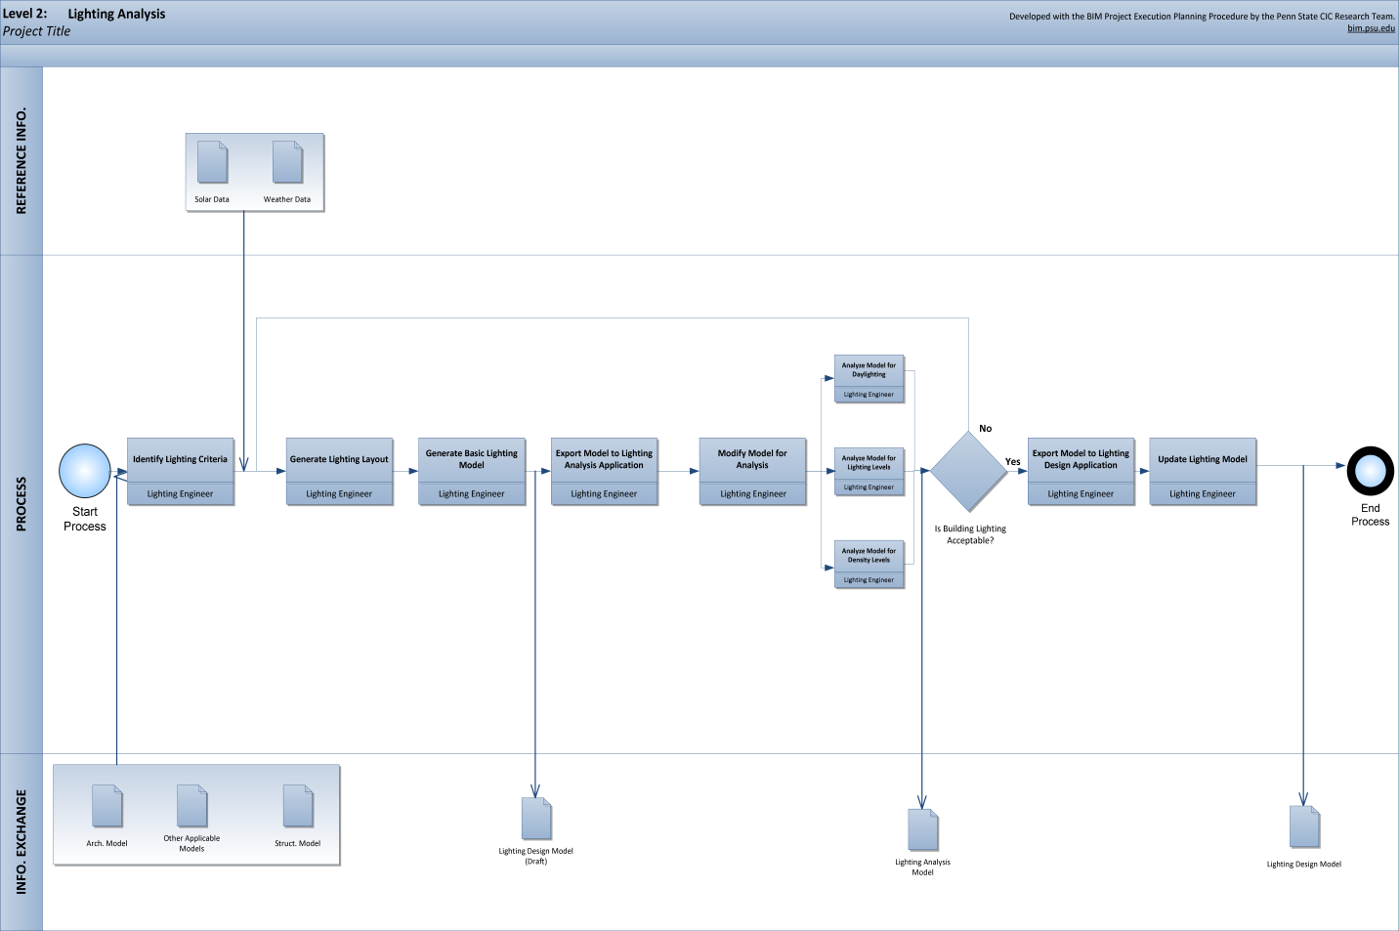

BIM Process
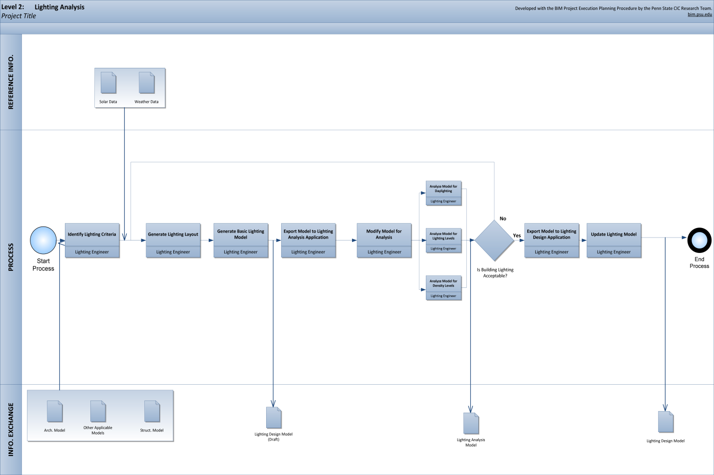

BIM Use Advancement Process

BIM Use Information Needs

Infrastructure
(Determine organizational Infrastructure Needs for Each Use

BIM Use Software Needs
(Summary of Software needed for the BIM Use. Include a C for current software or an N for software that needs to be purchased)
C/N | Software | Version

Hardware
(Summary of Hardware needed. Include a C for current software or an N for software that needs to be purchased)

C/N | Hardware | Specifications

Physical Spaces
(Summary of the physical spaces needed for the BIM Use)

Personnel
(Summary of Personnel Concerns including roles/ responsibilities, Organizational structure)

BIM Roles and Responsibilities
(Create a list of Personnel Roles and define their responsibilities within the BIM Uses)
C/N | Role | Responsibilities
 | BIM Champion

Education and Training Program
(Summarize the Education and Training Needs for the BIM Use

Change Management
(Document Change Management Considerations and Strategies

Attachments:
(Please create a comprehensive list of attachment)

