BIM PROJECT EXECUTION PLAN
Version 2.0
FOR
[PROJECT TITLE]
DEVELOPED BY
[AUTHOR COMPANY]

This template is a tool that is provided to assist in the development of a BIM project execution plan as required per contract. The template plan was created from the buildingSMART alliance™ (bSa) Project “BIM Project Execution Planning” as developed by The Computer Integrated Construction (CIC) Research Group of The Pennsylvania State University. The bSa project is sponsored by The Charles Pankow Foundation (http://www.pankowfoundation.org), Construction Industry Institute (CII) (http://www.construction‐institute.org), Penn State Office of Physical Plant (OPP) (http://www.opp.psu.edu), and The Partnership for Achieving Construction Excellence (PACE) (http://www.engr.psu.edu/pace). The BIM Project Execution Planning Guide can be downloaded at http://www.engr.psu.edu/BIM/PxP.

This coversheet can be replaced by a company specific coversheet that includes at a minimum document title, project title, project location, author company, and project number.

This work is licensed under the Creative Commons Attribution-Share Alike 3.0 United States License. To view a copy of this license, visit http://creativecommons.org/licenses/by-sa/3.0/us/ or send a letter to Creative Commons, 171 Second Street, Suite 300, San Francisco, California, 94105, USA.

BIM PROJECT EXECUTION PLAN
Version 2.0
FOR
[PROJECT TITLE]
DEVELOPED BY
[AUTHOR COMPANY]

Table of Contents
Section A: BIM Project Execution Plan Overview 1
Section B: Project Information 2
Section C: Key Project Contacts 3
Section D: Project Goals / BIM Uses 4
Section E: Organizational Roles / Staffing 5
Section F: BIM Process Design 6
Section G: BIM Information Exchanges 7
Section H: BIM and Facility Data Requirements 8
Section I: Collaboration Procedures 9
Section J: Quality Control 11
Section K: Technological Infrastructure Needs 12
Section L: Model Structure 13
Section M: Project Deliverables 14
Section N: Delivery Strategy / Contract 15
Section O: Attachments 16

Section A: BIM Project Execution Plan Overview
To successfully implement Building Information Modeling (BIM) on a project, the project team has developed this detailed BIM Project Execution Plan. The BIM Project Execution Plan defines uses for BIM on the project (e.g. design authoring, cost estimating, and design coordination), along with a detailed design of the process for executing BIM throughout the project lifecycle.
[INSERT ADDITIONAL INFORMATION HERE IF APPLICABLE. FOR EXAMPLE: BIM MISSION STATEMENT This is the location to provide additional BIM overview information. Additional detailed information can be included as an attachment to this document.
Please note: Instructions and examples to assist with the completion of this guide are currently in grey. The text can and should be modified to suit the needs of the organization filling out the template. If modified, the format of the text should be changed to match the rest of the document. This can be completed, in most cases, by selecting the normal style in the template styles.

Section B: Project Information
This section defines basic project reference information and determined project milestones.
- Project Owner:
- Project Name:
- Project Location and Address:
- Contract Type / Delivery Method:
- Brief Project Description: [NUMBER OF FACILITIES, GENERAL SIZE, ETC]
- Additional Project Information: [UNIQUE BIM PROJECT CHARACTERISTICS AND REQUIREMENTS]
- Project Numbers:
PROJECT INFORMATION | NUMBER
CONTRACT NUMBER:
TASK ORDER:
PROJECT NUMBER:
- Project Schedule / Phases / Milestones:
Include BIM milestones, pre-design activities, major design reviews, stakeholder reviews, and any other major events which occur during the project lifecycle.
PROJECT PHASE /  MILESTONE | ESTIMATED START DATE | ESTIMATED COMPLETION DATE | PROJECT STAKEHOLDERS INVOLVED
PRELIMINARY PLANNING
DESIGN DOCUMENTS
CONSTRUCTION DOCUMENTS
CONSTRUCTION

Section C: Key Project Contacts
List of lead BIM contacts for each organization on the project. Additional contacts can be included later in the document.
Role | Organization | Contact Name | Location | E-Mail | Phone
Project Manager(s)
BIM Manager(s)
Discipline Leads
Other Project Roles

Section D: Project Goals / BIM Uses
Describe how the BIM Model and Facility Data are leveraged to maximize project value (e.g. design alternatives, life-cycle analysis, scheduling, estimating, material selection, pre-fabrication opportunities, site placement, etc.) Reference www.engr.psu.edu/bim/download for BIM Goal & Use Analysis Worksheet.
- Major BIM Goals / Objectives:
State Major BIM Goals and Objectives
PRIORITY  (HIGH/ MED/ LOW) | GOAL DESCRIPTION | POTENTIAL BIM USES
- BIM Use Analysis Worksheet: Attachment 1
Reference www.engr.psu.edu/bim/download for BIM Goal & Use Analysis Worksheet. Attach BIM Use analysis Worksheet as Attachment 1.
- BIM Uses:
Highlight and place an X next to the additional BIM Uses to be developed by the use of the BIM model as selected by the project team using the BIM Goal & Use Analysis Worksheet. See BIM Project Execution Planning Guide at www.engr.psu.edu/BIM/BIM_Uses for Use descriptions. Include additional BIM Uses as applicable in empty cells.

X | PLAN | X | DESIGN | X | CONSTRUCT | X | OPERATE
 | PROGRAMMING |  | DESIGN AUTHORING |  | SITE UTILIZATION PLANNING |  | BUILDING MAINTENANCE SCHEDULING
 | SITE ANALYSIS |  | DESIGN REVIEWS |  | CONSTRUCTION SYSTEM DESIGN |  | BUILDING SYSTEM ANALYSIS
 |  |  | 3D COORDINATION |  | 3D COORDINATION |  | ASSET MANAGEMENT
 |  |  | STRUCTURAL ANALYSIS |  | DIGITAL FABRICATION |  | SPACE MANAGEMENT / TRACKING
 |  |  | LIGHTING ANALYSIS |  | 3D CONTROL AND PLANNING |  | DISASTER PLANNING
 |  |  | ENERGY ANALYSIS |  | RECORD MODELING |  | RECORD MODELING
 |  |  | MECHANICAL ANALYSIS
 |  |  | OTHER ENG. ANALYSIS
 |  |  | SUSTAINABLITY (LEED) EVALUATION
 |  |  | CODE VALIDATION
 | PHASE PLANNING  (4D MODELING) |  | PHASE PLANNING  (4D MODELING) |  | PHASE PLANNING  (4D MODELING) |  | PHASE PLANNING  (4D MODELING)
 | COST ESTIMATION |  | COST ESTIMATION |  | COST ESTIMATION |  | COST ESTIMATION
 | EXISTING CONDITIONS MODELING |  | EXISTING CONDITIONS MODELING |  | EXISTING CONDITIONS MODELING |  | EXISTING CONDITIONS MODELING

Section E: Organizational Roles / Staffing
Determine the project’s BIM Roles/Responsibilities and BIM Use Staffing
- BIM Roles and Responsibilities:
Describe BIM roles and responsibilities such as BIM Managers, Project Managers, Draftspersons, etc.

- BIM Use Staffing:
For each BIM Use selected, identify the team within the organization (or organizations) who will staff and perform that Use and estimate the personal time required.
BIM Use | Organization | Number of Total Staff for BIM Use | Estimated Worker Hours | Location(s) | Lead Contact
3D coordination | Contractor A
 | B
 | C

Section F: BIM Process Design
Provide process maps for each BIM Use selected in section D: Project Goals/BIM Objectives. These process maps provide a detailed plan for execution of each BIM Use. They also define the specific Information Exchanges for each activity, building the foundation for the entire execution plan. The plan includes the Overview Map (Level 1) of the BIM Uses, a Detailed Map of each BIM Use (Level 2), and a description of elements on each map, as appropriate. Level 1 and 2 sample maps are available for download at www.engr.psu.edu/BIM/download. (Please note that these are sample maps and should be modified based on project specific information and requirements). Please reference Chapter Three: Designing BIM Project Execution Process in the BIM Project Execution Planning Guide found at www.engr.psu.edu/BIM/PxP
- Level One Process Overview Map: Attachment 2

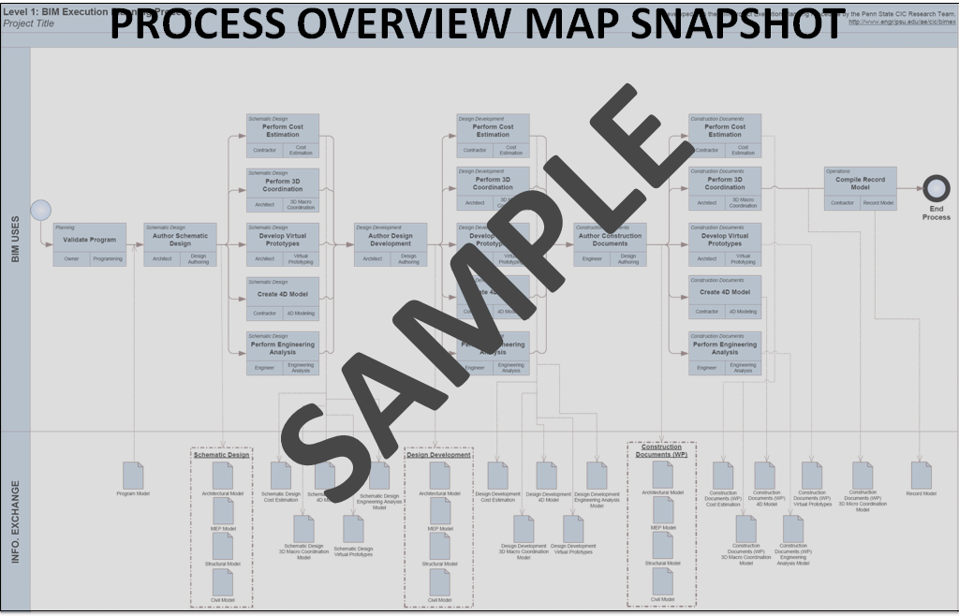
- List of Level Two – Detailed BIM Use Process Map(s): Attachment 3
The following are examples. Modify for specific project. Some Process Maps may need to be removed, while some process maps may need to be added.
  - Existing Conditions Modeling
  - Cost Estimation
  - Phase Planning (4D Modeling)
  - Programming
  - Site Analysis
  - Design Reviews
  - Design Authoring
  - Energy Analysis
  - Structural Analysis
  - Lighting Analysis
  - 3D Coordination
  - Site Utilization Planning
  - 3D Control and Planning
  - Record Modeling
  - Maintenance Scheduling
  - Building System Analysis
[Delete unused or add additional process maps from list]

Section G: BIM Information Exchanges
Model elements by discipline, level of detail, and any specific attributes important to the project are documented using information exchange worksheet. See Chapter Four: Defining the Requirements for Information Exchanges in the BIM Project Execution Planning Guide for details on completing this template.
- List of Information Exchange Worksheet(s): Attachment 4
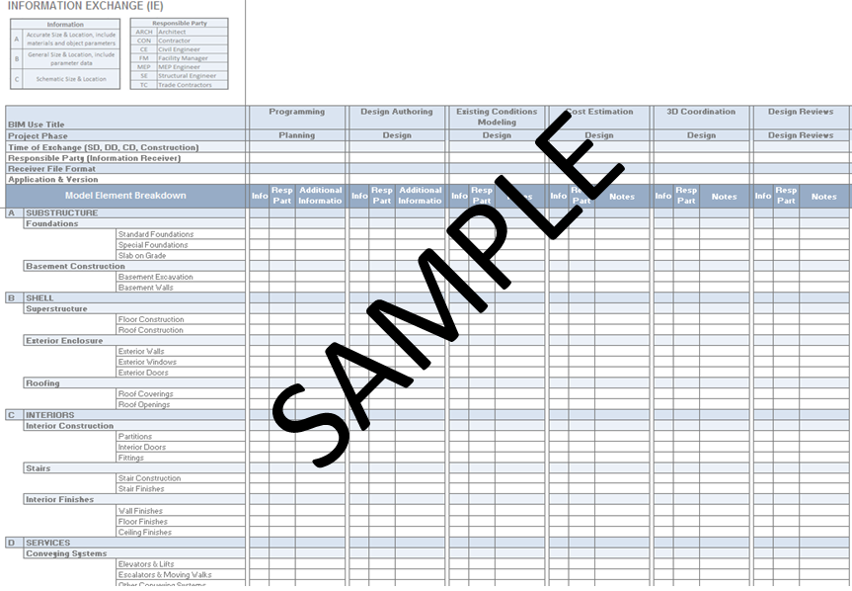
The following are examples. Modify for specific project. Some Information Exchanges may need to be removed, while some Information Exchanges may need to be added.
  - Existing Conditions Modeling
  - Cost Estimation
  - Phase Planning (4D Modeling)
  - Programming
  - Site Analysis
  - Design Reviews
  - Design Authoring
  - Energy Analysis
  - Structural Analysis
  - Lighting Analysis
  - 3D Coordination
  - Site Utilization Planning
  - 3D Control and Planning
  - Record Modeling
  - Maintenance Scheduling
  - Building System Analysis
  - [Delete unused information exchanges from list]

- Model Definition Worksheet: Attachment 5
(Attach Model Definition Worksheet)
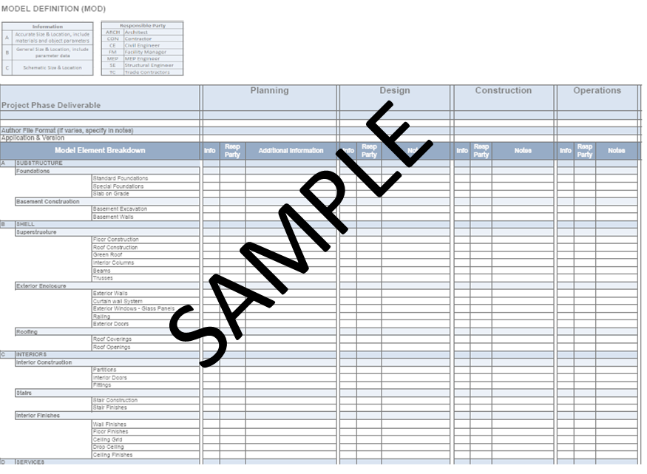

Section H: BIM and Facility Data Requirements
The section should include the owners BIM requirements. It is important that the owner’s requirements for BIM be considered so that they can be incorporated into the project’s BIM process.

Section I: Collaboration Procedures
- Collaboration Strategy:
Describe how the project team will collaborate. Include items such as communication methods, document management and transfer, and record storage, etc.
- Meeting Procedures:
The following are examples of meetings that should be considered.
MEETING TYPE | PROJECT STAGE | FREQUENCY | PARTICIPANTS | LOCATION
BIM REQUIREMENTS KICK-OFF
BIM EXECUTION PLAN DEMONSTRATION
DESIGN COORDINATION
CONSTRUCTION OVER-THE-SHOULDER PROGRESS REVIEWS
ANY OTHER BIM MEETINGS THAT OCCURS WITH MULTIPLE PARTIES

- Model Delivery Schedule of Information Exchange for Submission and Approval:
Document the information exchanges and file transfers that will occur on the project.
INFORMATION EXCHANGE | FILE  SENDER | FILE  RECEIVER | ONE-TIME or FREQUENCY | DUE DATE or START DATE | MODEL FILE | MODEL SOFTWARE | NATIVE FILE TYPE | FILE EXCHANGE TYPE
DESIGN AUTHORING - 3D COORDINATION | STRUCTURAL ENGINEER | (FTP POST)  (COORDINATION LEAD) | WEEKLY | [DATE] | STRUCT | DESIGN APP | .XYZ | .XYZ  .ABC
 | MECHANICAL ENGINEER | (FTP POST)  (COORDINATION LEAD) | WEEKLY | [DATE] | MECH | DESIGN APP | .XYZ | .XYZ  .ABC

- Interactive Workspace
The project team should consider the physical environment it will need throughout the lifecycle of the project to accommodate the necessary collaboration, communication, and reviews that will improve the BIM Plan decision making process. Describe how the project team will be located. Consider questions like “will the team be collocated?” If so, where is the location and what will be in that space? Will there be a BIM Trailer? If yes, where will it be located and what will be in the space such as computers, projectors, tables, table configuration? Include any additional information necessary information about workspaces on the project.

- Electronic Communication Procedures:
(Note: File Naming and Folder Structure will be discussed in Section L: Model Structure).
The following document management issues should be resolved and a procedure should be defined for each: Permissions / access, File Locations, FTP Site Location(s), File Transfer Protocol, File / Folder Maintenance, etc.

FILE LOCATION | FILE STRUCTURE / NAME |  |  | FILE TYPE | PASSWORD PROTECT | FILE  MAINTAINER | UPDATED
FTP SITE:  ftp://ftp.****.com/***/**** | ROOT PROJECT FOLDER |  |  | FOLDER | YES  *********** | JIM McBIM | ONCE
 |  | ARCH ROOT FOLDER |  | FOLDER |  |  | ONCE
 |  |  | ARCH-11111-BL001.xyz | .xyz |  |  | DAILY
NETWORK drive @ PSU  F:\PROJECT\BIM | ROOT PROJECT FOLDER |  |  | FOLDER | NO | JIM McBIM | ONCE
Project Management Software
www.*****.com

Section J: Quality Control
- OVERALL STRATEGY FOR QUALITY CONTROL:
Describe the strategy to control the quality of the model.
- QUALITY CONTROL CHECKS:
The following checks should be performed to assure quality.
CHECKS | DEFINITION | RESPONSIBLE PARTY | SOFTWARE PROGRAM(S) | FREQUENCY
VISUAL CHECK | Ensure there are no unintended model components and the design intent has been followed
INTERFERENCE CHECK | Detect problems in the model where two building components are clashing including soft and hard
STANDARDS CHECK | Ensure that the BIM and AEC CADD Standard have been followed (fonts, dimensions, line styles, levels/layers, etc)
MODEL INTEGRITY CHECKS | Describe the QC validation process used to ensure that the Project Facility Data set has no undefined, incorrectly defined or duplicated elements and the reporting process on non-compliant elements and corrective action plans

- Model Accuracy and Tolerances:
Models should include all appropriate dimensioning as needed for design intent, analysis, and construction. Level of detail and included model elements are provided in the Information Exchange Worksheet.
PHASE | DISCIPLINE | TOLERANCE
DESIGN DOCUMENTS | ARCH | ACCURATE TO +/- [ # ] OF ACTUAL SIZE AND LOCATION
SHOP DRAWINGS | MECH CONTRACTOR | ACCURATE TO +/- [ # ] OF ACTUAL SIZE AND LOCATION

Section K: Technological Infrastructure Needs
- Software:
List software used to deliver BIM. Remove software that is not applicable.

BIM USE | DISCIPLINE  (if applicable) | SOFTWARE | VERSION
DESIGN AUTHORING | ARCH | XYZ DESIGN APPLICATION | VER. X.X (YEAR)

- Computers / Hardware:
Understand hardware specification becomes valuable once information begins to be shared between several disciplines or organizations. It also becomes valuable to ensure that the downstream hardware is not less powerful than the hardware used to create the information. In order to ensure that this does not happen, choose the hardware that is in the highest demand and most appropriate for the majority of BIM Uses.
BIM USE | HARDWARE | OWNER OF HARDWARE | SPECIFICATIONS
DESIGN AUTHORING | XXX COMPUTER SYSTEM | ARCHITECT X | PROCESSOR, OPERATING SYSTEM, MEMORY STORAGE, GRAPHICS, NETWORK CARD, ETC.

- Modeling Content and Reference Information
Identify items such as families, workspaces, and databases.
BIM USE | DISCIPLINE  (if applicable) | MODELING CONTENT /  REFERENCE INFORMATION | VERSION
DESIGN AUTHORING | ARCH | XYZ APP FAMILIES | VER. X.X. (YEAR)
ESTIMATING | CONTRACTOR | PROPRIETARY DATABASE | VER. X.X (YEAR)

Section L: Model Structure
- File Naming Structure:
Determine and list the structure for model file names.
FILE NAMES FOR MODELS SHOULD BE FORMATTED AS:
DISCIPLINE - PROJECT NUMBER – BUILDING NUMBER.XYZ (example: ARCH-11111-BL001.xyz)
ARCHITECTURAL MODEL | ARCH-
CIVIL MODEL | CIVIL-
MECHANICAL MODEL | MECH-
PLUMBING MODEL | PLUMB-
ELECTRICAL MODEL | ELEC-
STRUCTURAL MODEL | STRUCT-
ENERGY MODEL | ENERGY-
CONSTRUCTION MODEL | CONST-
COORDINATION MODEL | COORD-

- Model Structure:
Describe and diagram how the Model is separated, e.g., by building, by floors, by zone, by areas, and/or discipline.
- Measurement and Coordinate Systems:
Describe the measurement system (Imperial or Metric) and coordinate system (geo-referenced) used.
- BIM and CAD Standards:
Identify items such as the BIM and CAD standards, content reference information, and the version of IFC, etc.
STANDARD | VERSION | BIM USES APLICABLE | ORGANIZATIONS APLICABLE
CAD STANDARD |  | DESIGN AUTHORING | ARCHITECT
IFC | VERSION/MVD(s) | RECORD MODELING | CONSTRUTION MANAGER

Section M: Project Deliverables
In this section, list the BIM deliverables for the project and the format in which the information will be delivered.
BIM SUBMITTAL ITEM | STAGE | Approximate Due Date | FORMAT | NOTES
 | Design Development
Construction
Documents
 | Construction
Record Model | Close out |  | (.xyz) | See Record Model Information Exchange to ensure that the proper information is contained in this model

Section N: Delivery Strategy / Contract
- Delivery and Contracting Strategy for the project:
What additional measures need to be taken to successfully use BIM with the selected delivery method and contract type?
- Team Selection Procedure:
How will you select future team members in regards to the above delivery strategy and contract type?
- BIM Contracting Procedure:
How should BIM be written into the future contracts? (If documents / contracts are developed, please attach as attachment 6)

Section O: Attachments
- BIM USE SELECTION WORKSHEET [FROM SECTION D]
- LEVEL 1 PROCESS OVERVIEW MAP [FROM SECTION F]
- LEVEL 2 DETAILED BIM USE PROCESS MAP(S) [FROM SECTION F]
- INFORMATION EXCHANGE REQUIREMENT WORKSHEET(S) [FROM SECTION G]
- MODEL DEFINITION WORKSHEET [FROM SECTION G]
- DEVELOPED DOCUMENTS / CONTRACTS [FROM SECTION H]

