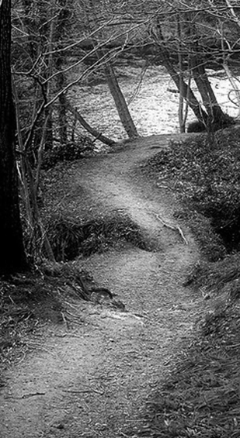
Reflecting on the Student Perspective
Don’t judge my path if you haven’t walked my journey.
-Source Unknown

Remember times when you were a learner. Think of a time when you
had each of the experiences below. Briefly describe the experience.
Try to respond to at least 5 of the 7.

1 | You were tasked with learning something, but you felt as if you really didn’t have enough prior knowledge to learn it
2 | You understood something in one way, but the person teaching you imagined, or hoped, you understood it (i.e., mentally organized it) in a different way
3 | You were learning something that you were not motivated to learn, because you just didn’t see the value in it
4 | You not only acquired knowledge or skills, but you knew how they connected with other knowledge and skills and you knew when to apply them
5 | You learned a skill that, at first, you weren’t very good at; but you got good at it
6 | You were in a learning environment that, while the content was relevant, the climate of the learning environment substantially impeded your learning
7 | You were able to manage your own learning of the content or completion of the task; You were aware of your progress and were responsible for adjustments

